**Exercise 4: Functions**

**Scenario 1: Calculate the age of customers for eligibility checks.**

**Question: Write a function CalculateAge that takes a customer's date of birth as input and returns their age in years.**

**Function Creation**

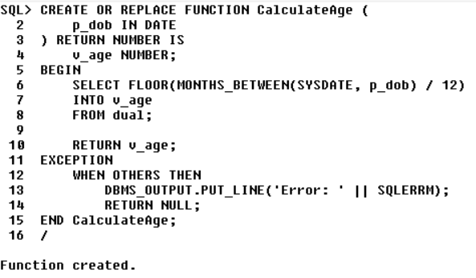

**Code Execution:**

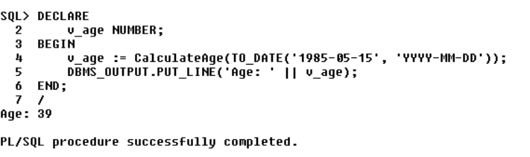

**Scenario 2: The bank wants to implement a bonus scheme for employees based on their performance.**

**Question: Write a stored procedure UpdateEmployeeBonus that updates the salary of employees in a given department by adding a bonus percentage passed as a parameter.**

**Function Creation**

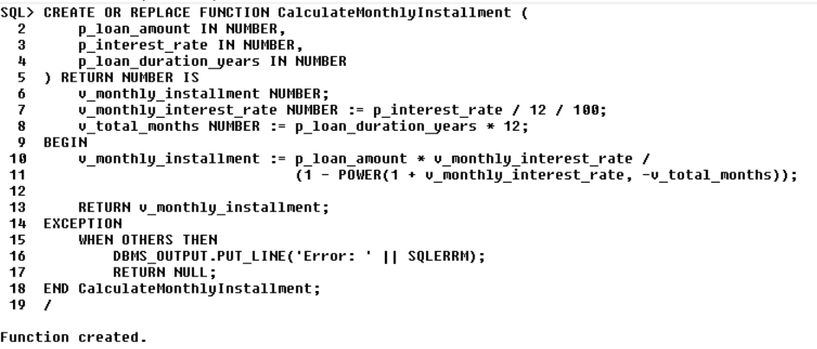

**Execution:**

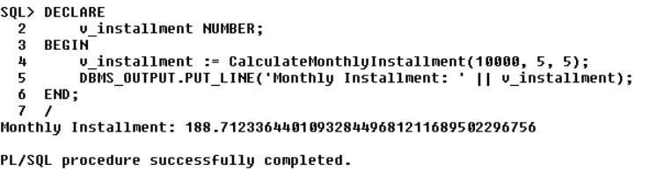

**Scenario 3: Customers should be able to transfer funds between their accounts.**

**Question: Write a stored procedure TransferFunds that transfers a specified amount from one account to another, checking that the source account has sufficient balance before making the transfer.**

**Function Creation**

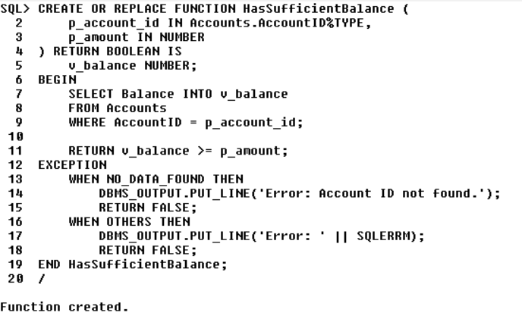

**Execution**

